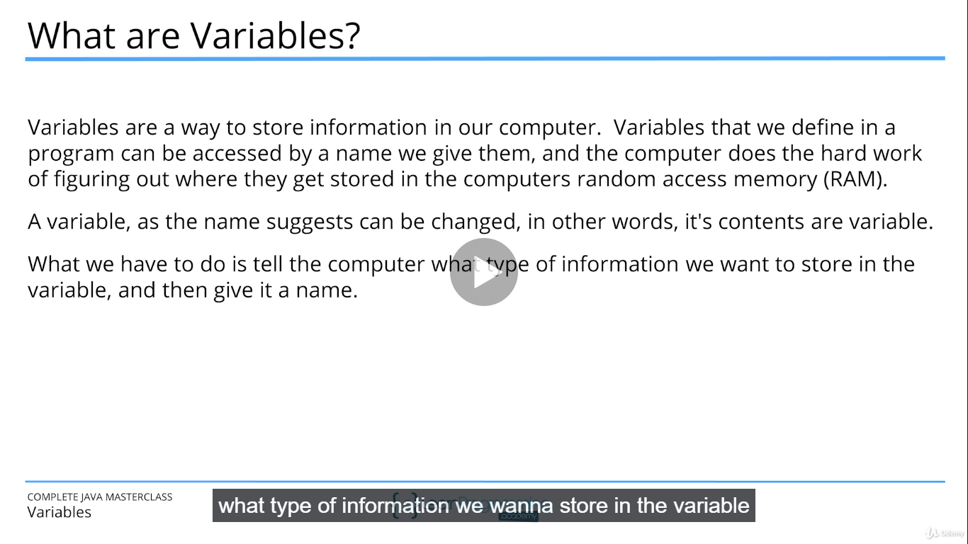

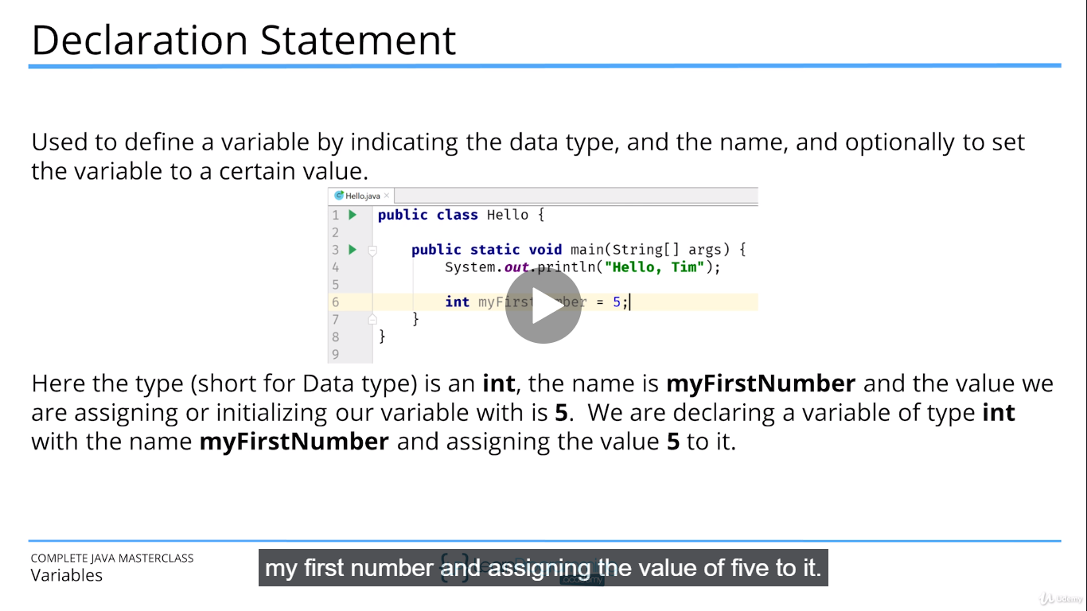

**SUM OF TWO NUMBERS**

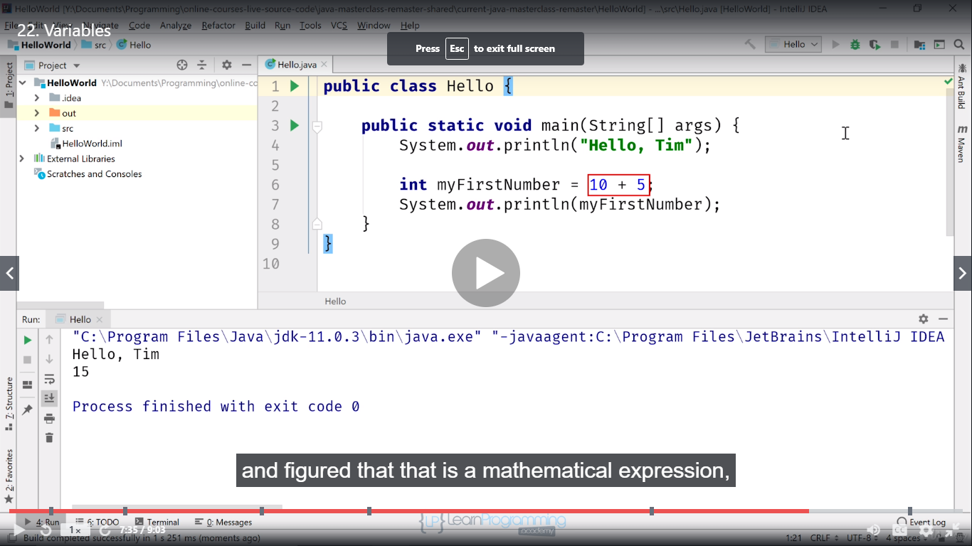

**PRIMITIVE DATA TYPE IN JAVA**

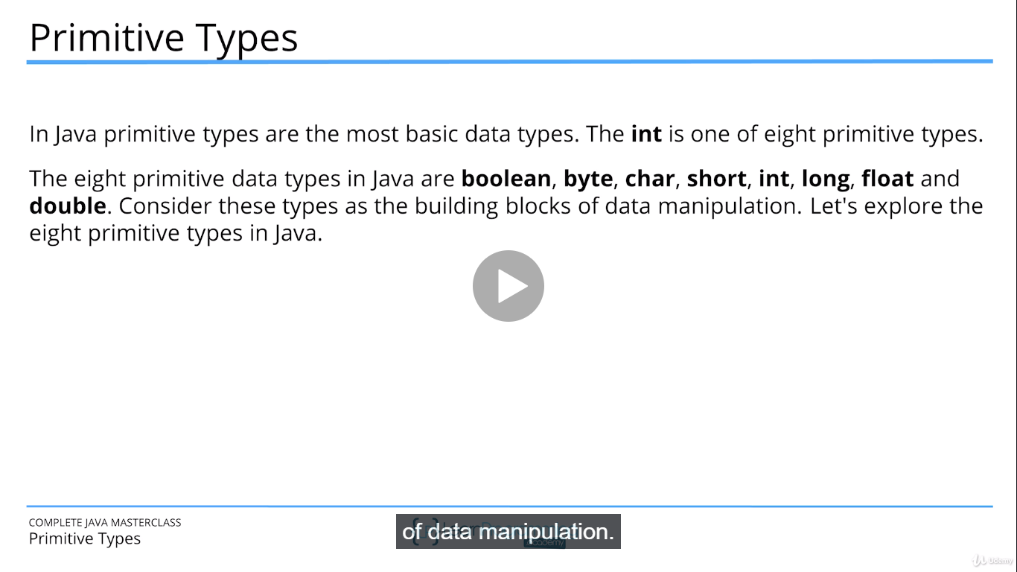

**WRAPPER CLASS**

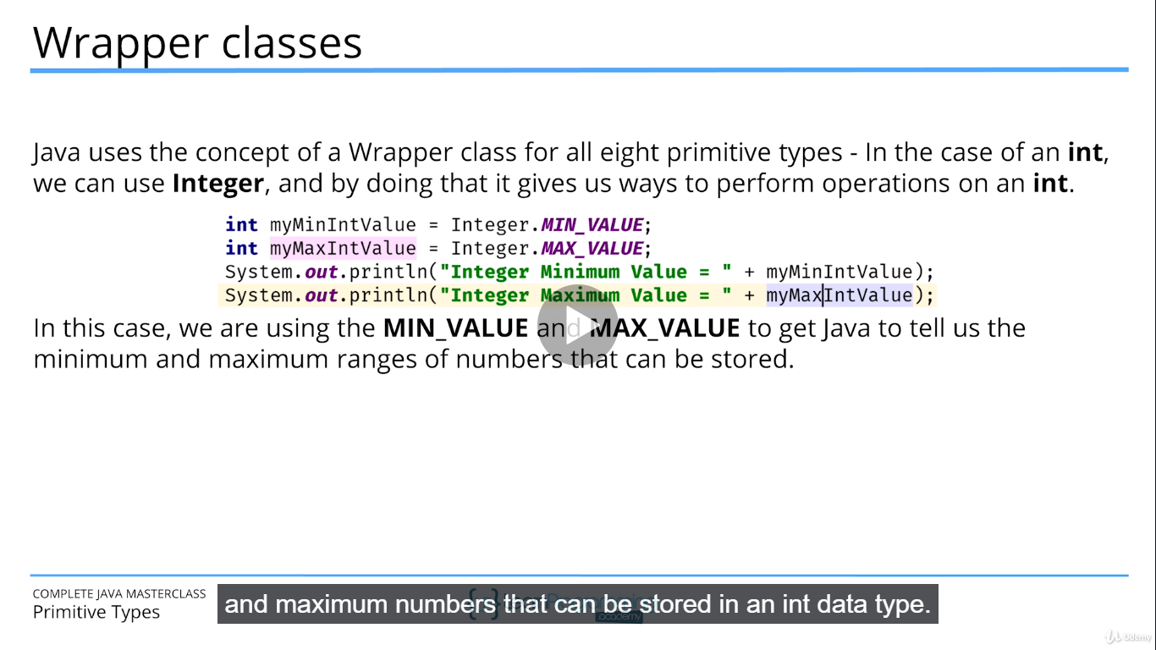

**OVERFLOW AND UNDERFLOW**

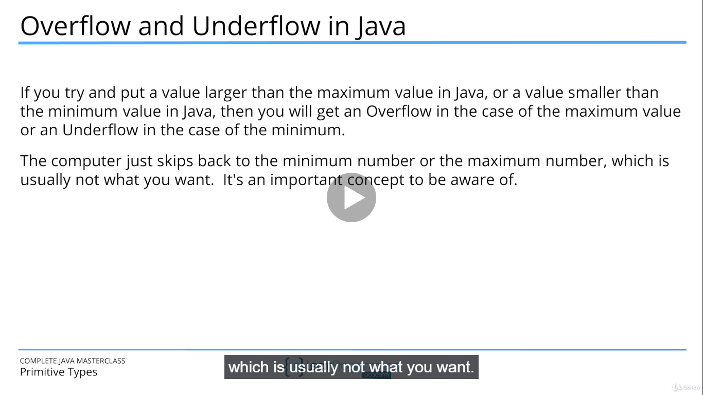

**CASTING IN JAVA**

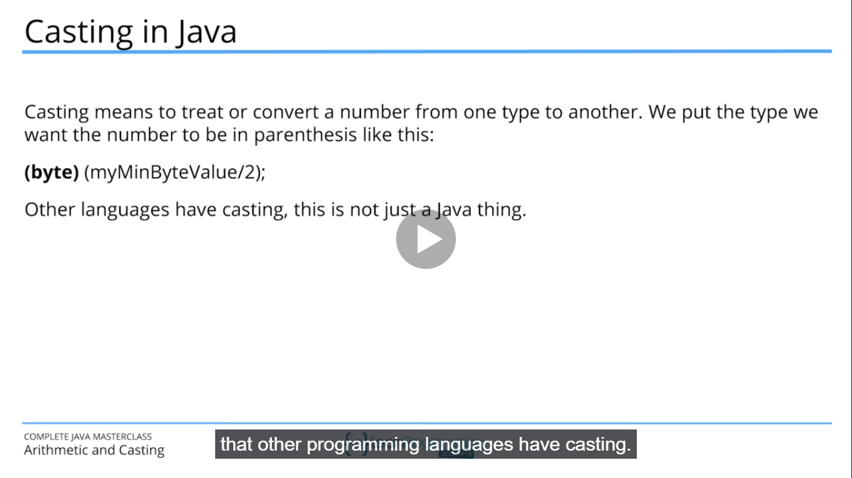

**FLOATING NUMBERS**

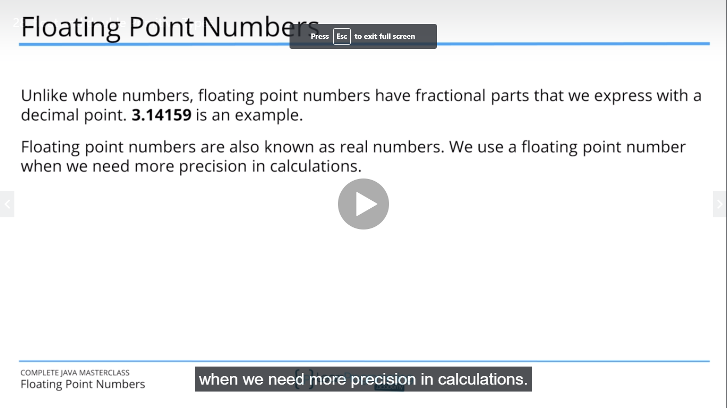

**UNICODE**

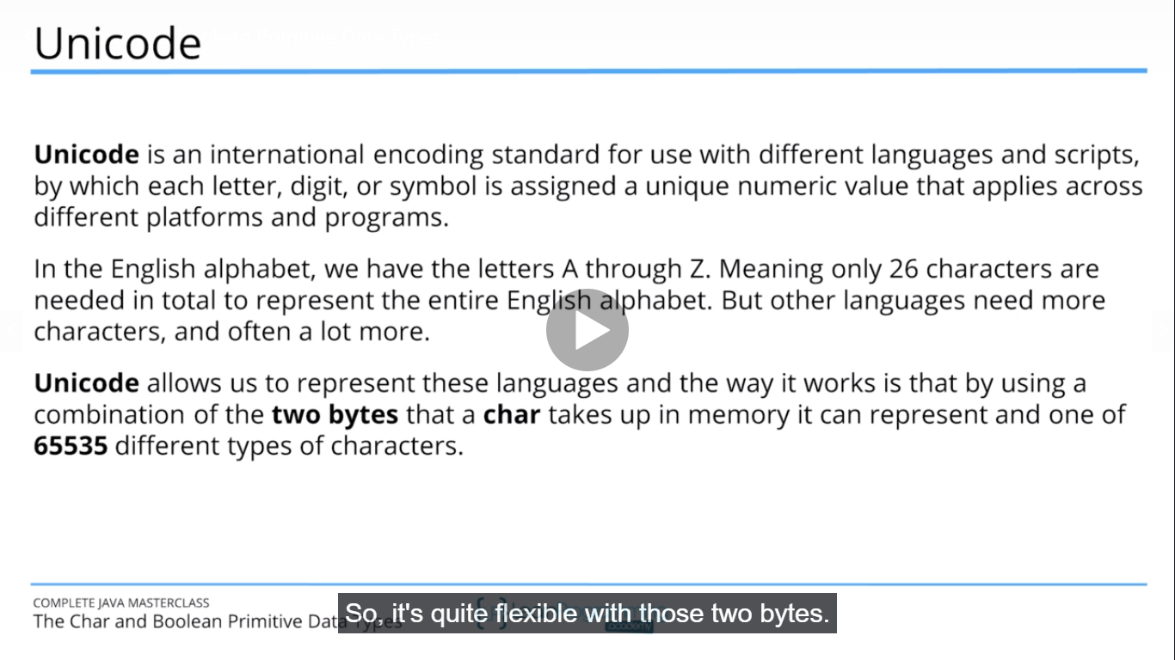

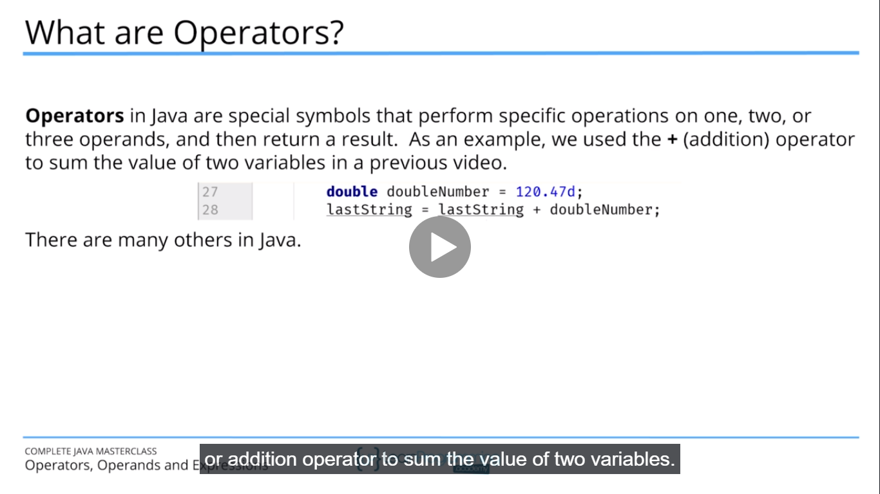

**OPERAND**

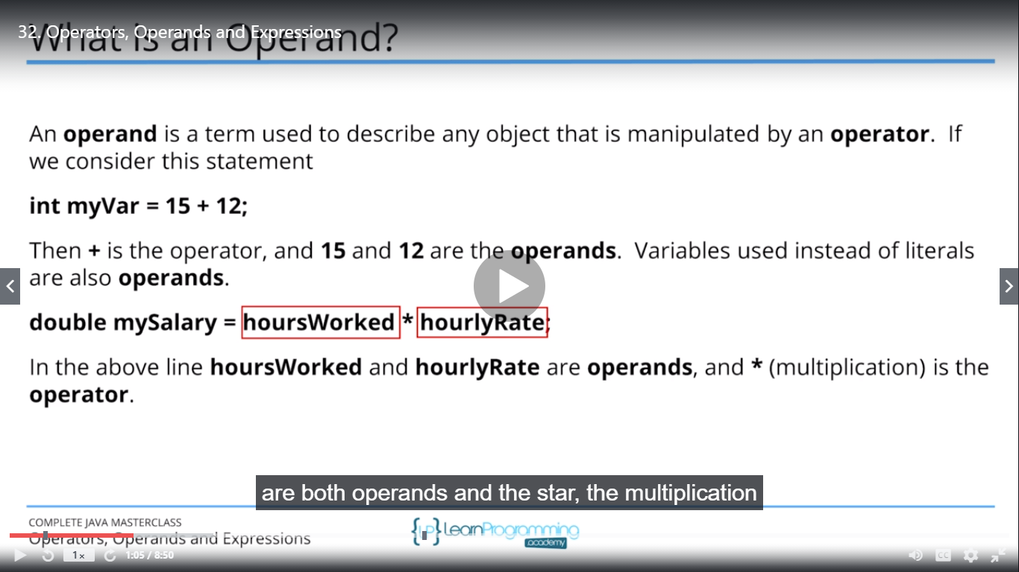

**OPERATOR CHALLENGE**

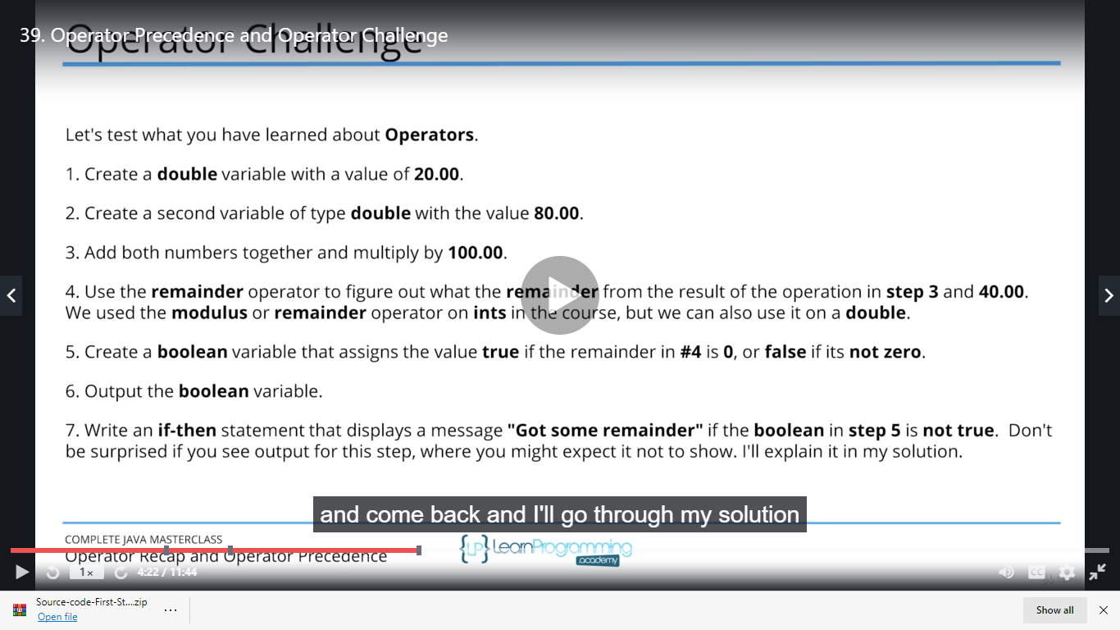

**CONCEPT OF REUSABLITY OF CODE**

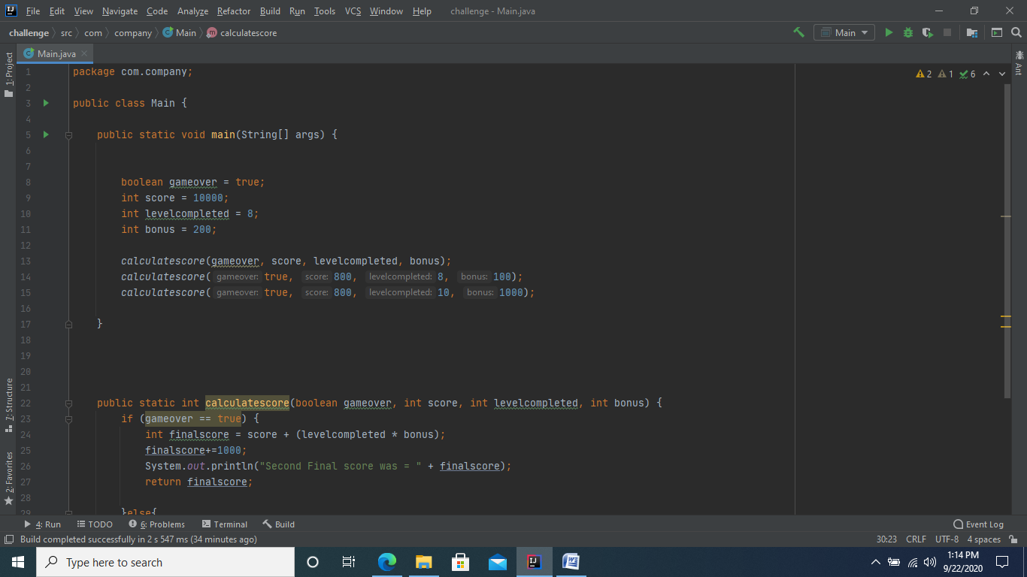

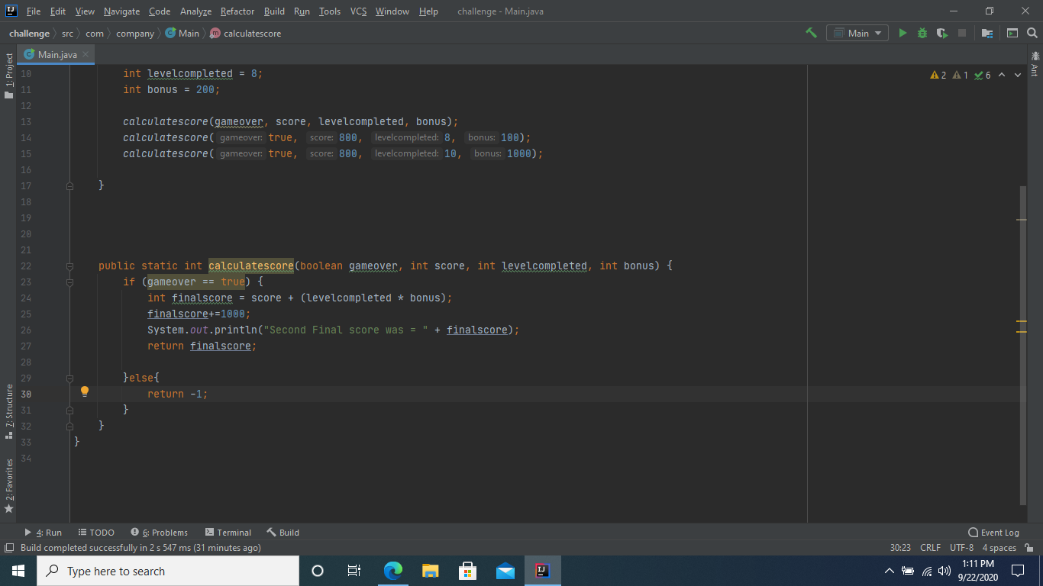

**WE HAVE TO RETURN -1 AS JAVA EXPECT THE VALUES FOR BOTH CONDITIONS EITHER IT IS TRUE OR FALSE BECAUSE OF THIS WE HAVE RETURN -1.**

**METHOD CHALLENGE**

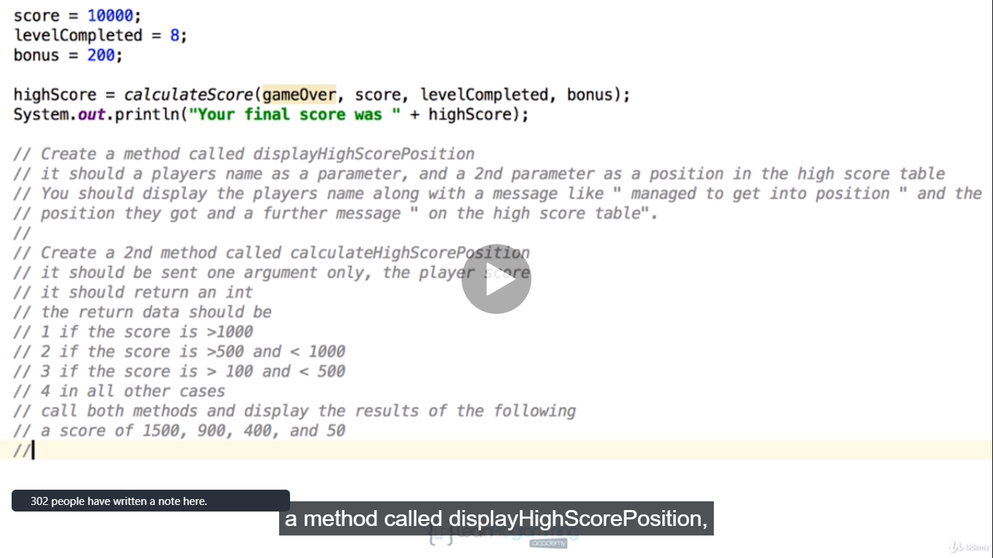

**METHOD OVERLOADING**

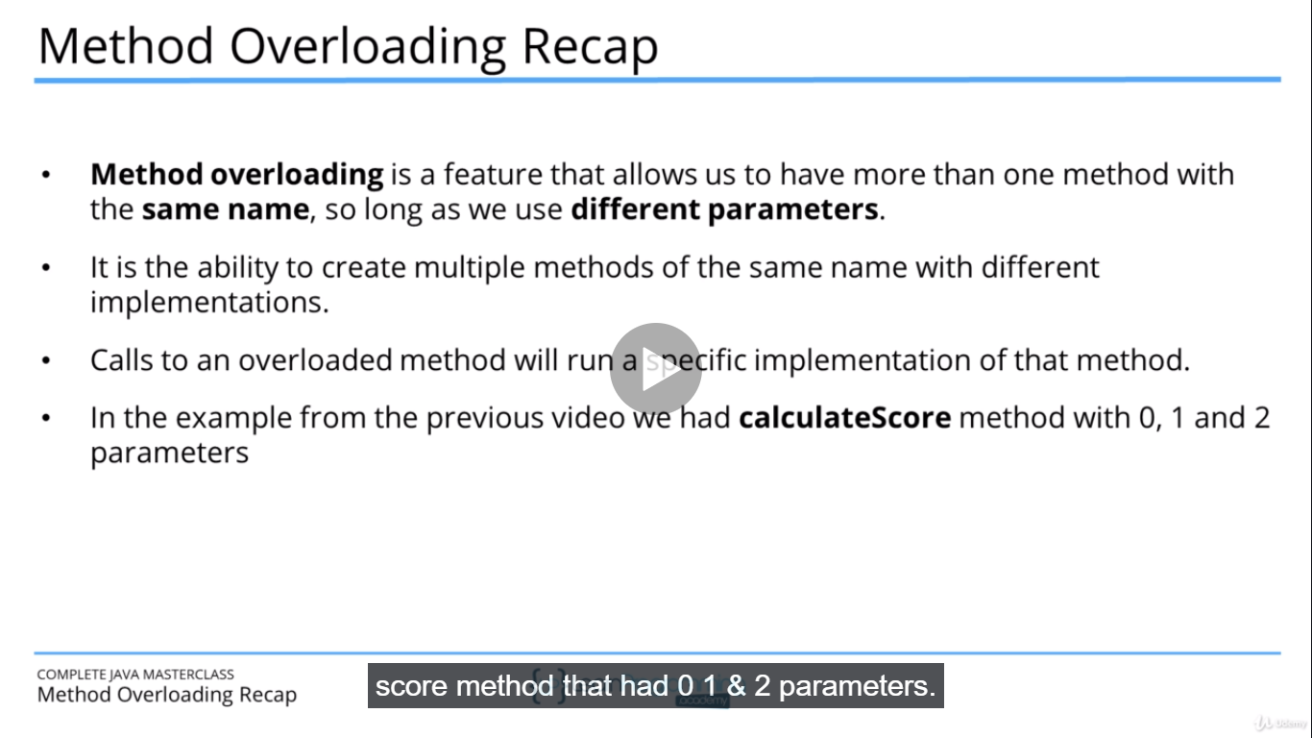

**SWITCH STATEMENT CHALLENGE (DAYS OF THE WEEK CHALLENGE).**

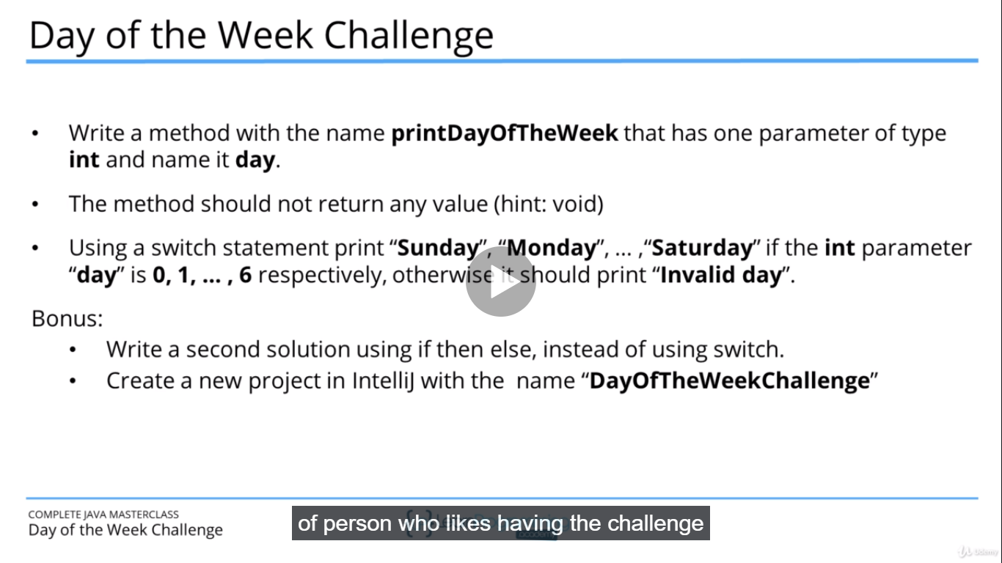

**WHILE STATEMENT WORKING**

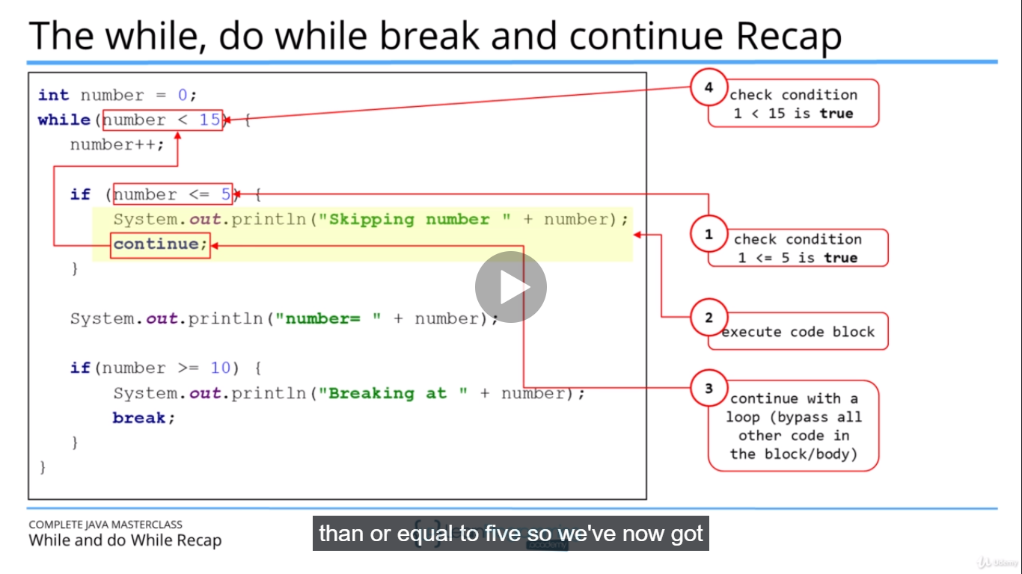

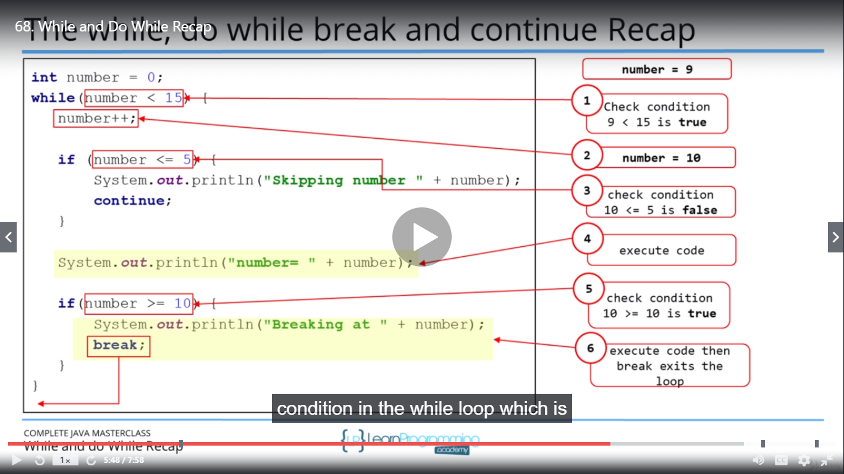

**DIGIT SUM CHALLENGE**

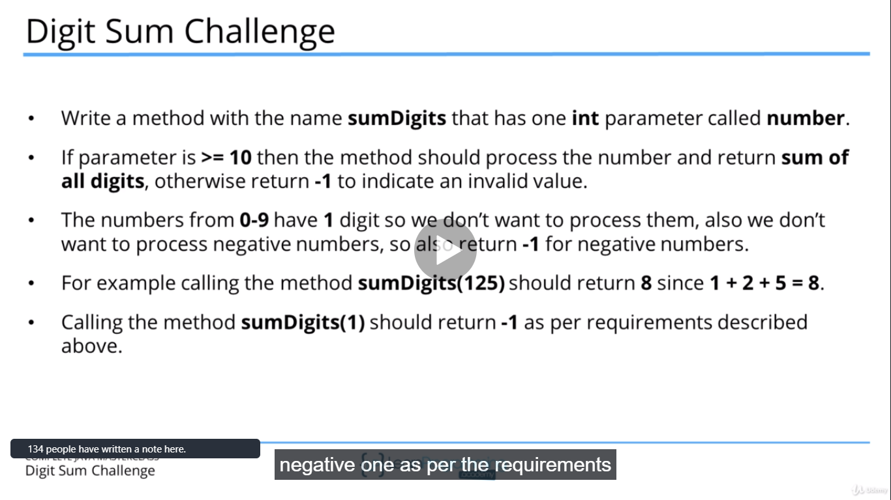

**JAVA FX**

